**Spatially explicit productivity and economic risks of rice planting date strategies for eastern Indo-Gangetic Plains**

# Abstract

Low crop yields of both wheat and rice in Bihar despite application of huge amounts of inorganic fertilizers and use of improved seed varieties raises serious concerns for sustainable agricultural development. Agronomic practices especially timely irrigation and early sowing have been heralded as potential options for increasing yields and economic benefits. In this paper, we use crop simulation and computational economic models of evaluating risky portfolios to spatially assess the economic potential of these agronomic practices. We find that #######.

# 1. Introduction

Hook

Recent studies (see, Hurley et al 2018, Suri 2011, Dercon et al ####) have shown that heterogeneity in returns to technology adoption and the associated risk preferences of farmers may result in lack of adoption of profitable agricultural innovations. Most of these studies have focused on use of inorganic fertilizers and hybrid seed varieties. In the context of the EIGP, the adoption of fertilizers and hybrids seeds is already high. With stagnant yields, it is prudent to focus on yield improving agronomic practices.

Question

Using exante regional gridded crop simulations, Urfels et al (2022) investigated the impact of different rice planting strategies on system level productivity, resilience, and environmental benefits. In this paper, we extend the exante analyses to consider impacts of rice planting strategies on crop level and system level productivity and economic risks.

Antecedents

This paper contributes to the literature on ex ante spatial economic assessment of agricultural innovations (e.g., Hurley et al 2018, McCullough et al 2022, and Harou et al 2017). Using long term weather data, crop simulation models, spatially explicit observed maize prices, and fertilizer prices, Hurley et al (2018) simulates whether weather risk affects the adoption of fertilizer and improved maize seeds. They use heterogeneity in soils and climate in a calibrated crop growth model to simulate the distributions of yields across adoption of fertilizer and improved maize seed scenarios. They also assessed the heterogeneity of farmer risk preferences. McCullough et al (2022) and Harou et al (2017) used data on experimental fertilizer application trials across SSA and Malawi respectively to assess the spatially explicit profitability of nitrogen fertilizer use.

Contribution

We specifically follow the approach proposed by Hurley et al (2018) to estimate willingness to pay bounds for a risk averse farmer to likely adopt an agricultural innovation. We depart from their approach in two substantial ways. First, we attempt the approach using mostly non-marketed agricultural inputs or heavily subsidized inputs which presents challenges for economic assessments. Second, instead of using one output, e.g., maize yield as in Hurley et al (2018), we consider a multi-output system. This allows the choices to include the decision to plant or not to plant a particular crop given the economic benefits that must be forgone.

Roadmap

# 2. Methods

## 2.1. Data

The data used in this paper is based on crop simulation model results reported in Urfels et al (2022).

Data challenges included

* Missing values in the outputs. We replaced all NAs with zero thus assuming crop failure.
* Zero values of outputs.
* Lack of spatially explicit input prices data for the scenarios under study.

## 2.2. Computational Models

### 2.2.1. Crop simulation model

We use seven scenarios from crop simulation results reported in Urfels et al (2022). The scenarios correspond to variation in among of irrigation, varietal duration and the planting of rice at the onset of the monsoon.

Table: Scenarios

|  |  |  |  |
| --- | --- | --- | --- |
| Scenario number | Rice | Wheat | Description |
| S0 | Farmer practice | Farmer practice | Farmers’ practice baseline without nutrient and water limitations to understand current limits |
| S1 | Fixed long (baseline) | Fixed long  (baseline) | Planting long duration variety at a fixed recommended date |
| S2 | Fixed medium | Fixed medium | Planting medium duration variety at a fixed recommended date |
| S3 | Onset long | Onset long | Planting long duration rice variety at the onset of monsoon |
| S4 | Onset long supp | Onset long supp | Supplementary irrigation for planting long duration varieties at monsoon onset |
| S5 | Onset medium | Onset medium |  |
| S6 | Onset medium supp | Onset medium supp | Supplementary irrigation for planting medium varieties at monsoon onset |

### 2.2.2. Computational spatial ex ante economic model under risk aversion

#### Yield risk

We compute spatially explicit willingness to pay bounds in rice and wheat yield equivalents for a risk averse farmer to definitely adopt or not adopt the interventions using second order stochastic dominance. Theoretically, second order stochastic dominance is related to the Arrow-Pratt measure risk aversion (Levy 2016).

Meyer (1977) proved a theorem that cumulative distribution function $F(x)$ stochastically dominating $G(x)$ in the second order with respect to utility function $k(x)$ is equivalent to $F\left(x\right)$ being preferred or indifferent to $G(x)$ by all agents who are risk averse than an agent with utility function $k(x)$.

This implies that any risk averse farmer is likely to adopt if the yield advantage is such that the technology second order stochastically dominates another technology.

We use a hypothetical experiment to demonstrate the approach (Figure #). Based on mean comparisons, $G$ is clearly better than $F$ and $Q$. If we think in terms of distributional differences using first order stochastic dominance (Haim levy 2016), $G$ is clearly better than $Q$ because the cumulative distribution curve of $G$ is wholly to the right of $Q$. Consider next the case of $G$ and $F$ which have crossing cumulative distribution functions. For that comparison, second order stochastic dominance is needed to compare the area below and above the intersections. Visually, it can be deduced that $G$ second order stochastically dominates $F$. Consider the case of $F$ and $Q$, even though these have the same mean, one would want to choose which technology is better. It is difficult to visually assess the second order stochastic dominance ordering for these technologies. Using our approach, it is indeed unclear whether F stochastically dominates Q.

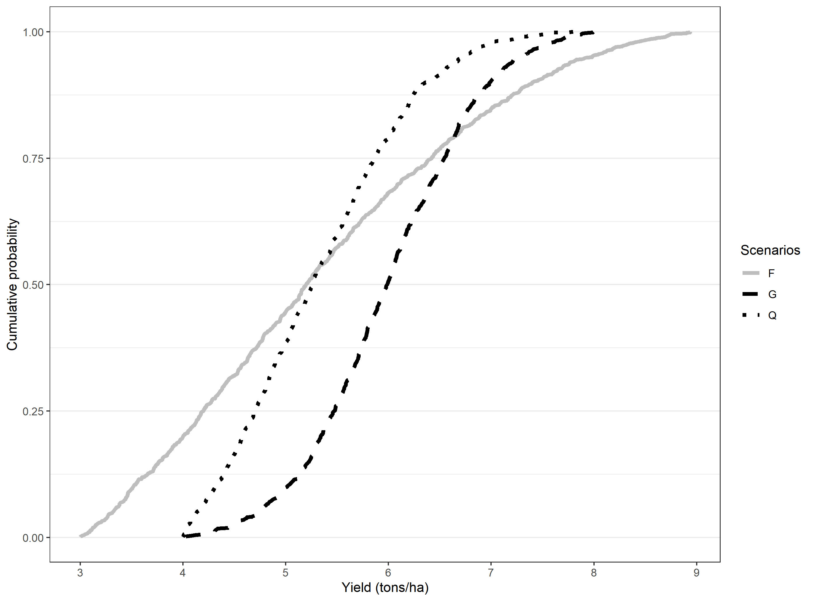

Figure: Hypothetical wheat/rice cumulative distribution comparisons

***Note:*** We use a truncated normal distribution with four parameters: minimum (a), maximum (b), mean, and standard deviation (sd). The parameters used for each of the scenarios are as follows: G= rtruncnorm (n=1000,a=4,b=8, mean=6,sd=0.8), Q=rtruncnorm (n=1000,a=4,b=8, mean=5,sd=1), F=rtruncnorm (n=1000,a=3,b=9, mean=5,sd=2).

Beyond establishing second order stochastic dominance, it is important to understand how much yield advantage is needed for one technology to second order dominate another. For this, we use an approximation to compute the lower and upper bounds for one technology to second order stochastically dominate another.

According to Hurley et al (2018), the lower WTP bound that makes any risk-averse farmer prefer new technology (in this case scenarios other than the baseline) can be derived using second order stochastic dominance as follows:

Where is the lower bound for the willingness to pay.

Similarly, for the upper bound,

If *both lower bound and upper bound are positive*, then any risk averse farmer will prefer $g$ to $r$. Conversely, if *both lower bound and upper bound are negative*, then any risk averse farmer will prefer $r$ to $g$.

#### Price risk

We use Octave for the computational analysis.

$$kg of wheat required to pay for technology per ha(kg/ha)=\frac{Technology cost per ha \left(\frac{Rs}{ha}\right) }{Price of wheat per kg (\frac{Rs}{kg})}$$

#### Stochastic Dominance and Cumulative Prospect Theory

# 3. Results and discussion

## 3.1. Yield benefits over baseline for risk averse farmer

Table # shows the descriptive statistics on the willingness to pay bounds.

Table: **Rice WTP bounds (t/ha)** with fixed long as baseline [without zero yield entries]

|  |  |  |  |  |  |  |  |
| --- | --- | --- | --- | --- | --- | --- | --- |
| Bound | Statistics | S0-S1 | S2-S1 | S3-S1 | S4-S1 | S5-S1 | S6-S1 |
| Upper bound | Weighted Mean_UB | 0.93 | 2.92 | 3.95 | 3.63 | 1.91 | 1.88 |
| Weighted SD_UB | 2.12 | 0.41 | 0.62 | 0.51 | 0.35 | 0.33 |
| Min_UB | -3.25 | 2.27 | 2.89 | 1.92 | 1.29 | 1.11 |
| Percentile10_UB | -1.42 | 2.50 | 3.18 | 3.06 | 1.55 | 1.50 |
| Percentile25_UB | -0.74 | 2.61 | 3.44 | 3.23 | 1.64 | 1.63 |
| Median_UB | 0.11 | 2.79 | 3.85 | 3.50 | 1.84 | 1.82 |
| Percentile75_UB | 3.08 | 3.18 | 4.40 | 3.97 | 2.13 | 2.09 |
| Percentile90_UB | 4.34 | 3.49 | 4.85 | 4.38 | 2.40 | 2.36 |
| Max_UB | 5.29 | 4.19 | 5.73 | 5.33 | 3.12 | 2.97 |
| Lower bound | WeightedMean_LB | -0.94 | 0.44 | 1.43 | 0.84 | -0.61 | -0.68 |
| WeightedSD_LB | 1.94 | 1.38 | 1.23 | 1.09 | 1.33 | 1.32 |
| Min_LB | -6.43 | -1.73 | -1.71 | -1.04 | -2.66 | -2.70 |
| Percentile10_LB | -3.15 | -1.31 | -0.10 | -0.36 | -2.24 | -2.29 |
| Percentile25_LB | -2.22 | -0.66 | 0.43 | -0.07 | -1.68 | -1.73 |
| Median_LB | -1.40 | 0.25 | 1.29 | 0.64 | -0.84 | -0.90 |
| Percentile75_LB | 0.04 | 1.37 | 2.27 | 1.52 | 0.28 | 0.19 |
| Percentile90_LB | 2.32 | 2.68 | 3.25 | 2.43 | 1.49 | 1.44 |
| Max_LB | 4.81 | 3.69 | 4.79 | 4.37 | 2.45 | 2.35 |
|  | Clearly better (share) | 0.26 | 0.57 | 0.87 | 0.72 | 0.29 | 0.28 |
| Not clear | 0.28 | 0.43 | 0.13 | 0.28 | 0.71 | 0.72 |
| Clearly worse (share) | 0.46 | 0.00 | 0.00 | 0.00 | 0.00 | 0.00 |
| Total hectares | 2179.00 | 3386.00 | 3386.00 | 3386.00 | 3386.00 | 3386.00 |
| Number of cells | 2179.00 | 3386.00 | 3386.00 | 3386.00 | 3386.00 | 3386.00 |

Table: **Wheat WTP bounds (t/ha)** with fixed long as baseline [without zero yield entries]

|  |  |  |  |  |  |  |  |
| --- | --- | --- | --- | --- | --- | --- | --- |
| Bound | Statistics | S0-S1 | S2-S1 | S3-S1 | S4-S1 | S5-S1 | S6-S1 |
| Upper bound | Weighted Mean_UB | 0.57 | 1.28 | 1.23 | 0.71 | 0.20 | -0.29 |
| Weighted SD_UB | 0.42 | 0.12 | 0.38 | 0.51 | 0.76 | 1.01 |
| Min_UB | 0.00 | 0.60 | 0.18 | -1.77 | -1.11 | -2.07 |
| Percentile10_UB | 0.08 | 1.15 | 0.64 | 0.02 | -0.80 | -1.72 |
| Percentile25_UB | 0.26 | 1.23 | 0.98 | 0.50 | -0.37 | -1.11 |
| Median_UB | 0.49 | 1.30 | 1.29 | 0.76 | 0.11 | -0.29 |
| Percentile75_UB | 0.83 | 1.37 | 1.50 | 1.05 | 0.82 | 0.53 |
| Percentile90_UB | 1.22 | 1.40 | 1.65 | 1.26 | 1.32 | 1.11 |
| Max_UB | 2.02 | 1.53 | 2.05 | 1.91 | 1.69 | 1.96 |
| Lower bound | WeightedMean_LB | 0.21 | 1.03 | 0.66 | 0.13 | -0.24 | -1.03 |
| WeightedSD_LB | 0.39 | 0.12 | 0.61 | 0.70 | 0.78 | 1.06 |
| Min_LB | -0.92 | 0.38 | -0.89 | -2.06 | -1.42 | -2.50 |
| Percentile10_LB | -0.02 | 0.88 | -0.26 | -0.94 | -1.08 | -2.01 |
| Percentile25_LB | 0.00 | 0.98 | 0.23 | -0.30 | -0.87 | -1.85 |
| Median_LB | 0.00 | 1.06 | 0.78 | 0.27 | -0.47 | -1.53 |
| Percentile75_LB | 0.30 | 1.11 | 1.17 | 0.65 | 0.36 | -0.38 |
| Percentile90_LB | 0.86 | 1.15 | 1.34 | 0.93 | 1.07 | 0.83 |
| Max_LB | 1.73 | 1.24 | 1.62 | 1.49 | 1.35 | 1.55 |
|  | Clearly better (share) | 0.43 | 1.00 | 0.80 | 0.65 | 0.31 | 0.21 |
| Not clear | 0.57 | 0.00 | 0.20 | 0.25 | 0.25 | 0.18 |
| Clearly worse (share) | 0.00 | 0.00 | 0.00 | 0.10 | 0.44 | 0.60 |
| Total hectares | 2612.00 | 3386.00 | 3386.00 | 3335.00 | 3386.00 | 3281.00 |
| Number of cells | 2612.00 | 3386.00 | 3386.00 | 3335.00 | 3386.00 | 3281.00 |

Figure: Maps showing locations where it is clearly beneficial as compared to baseline using second order stochastic dominance of yields

## 3.2. Price sensitivity and yield equivalent economic benefits for risk averse farmer

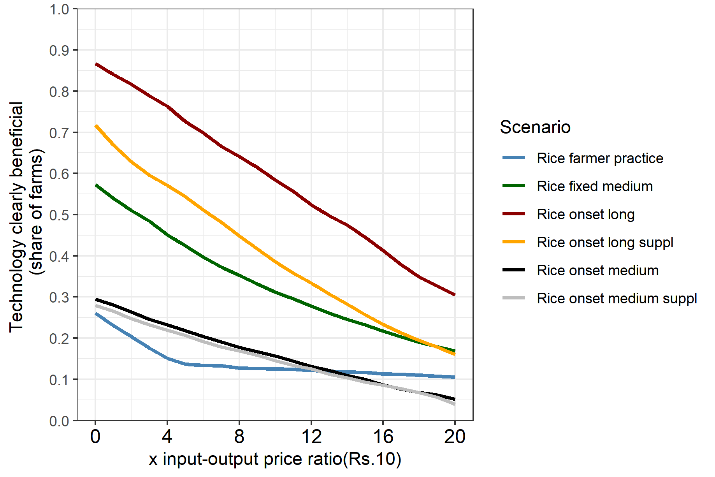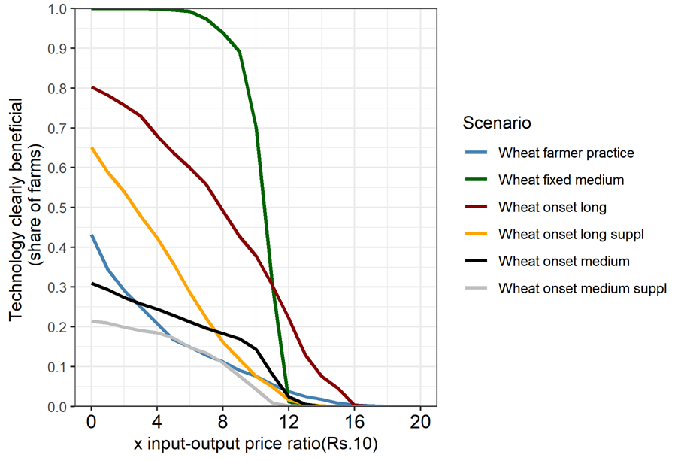

a. Without zero yield entries

Rice

Wheat

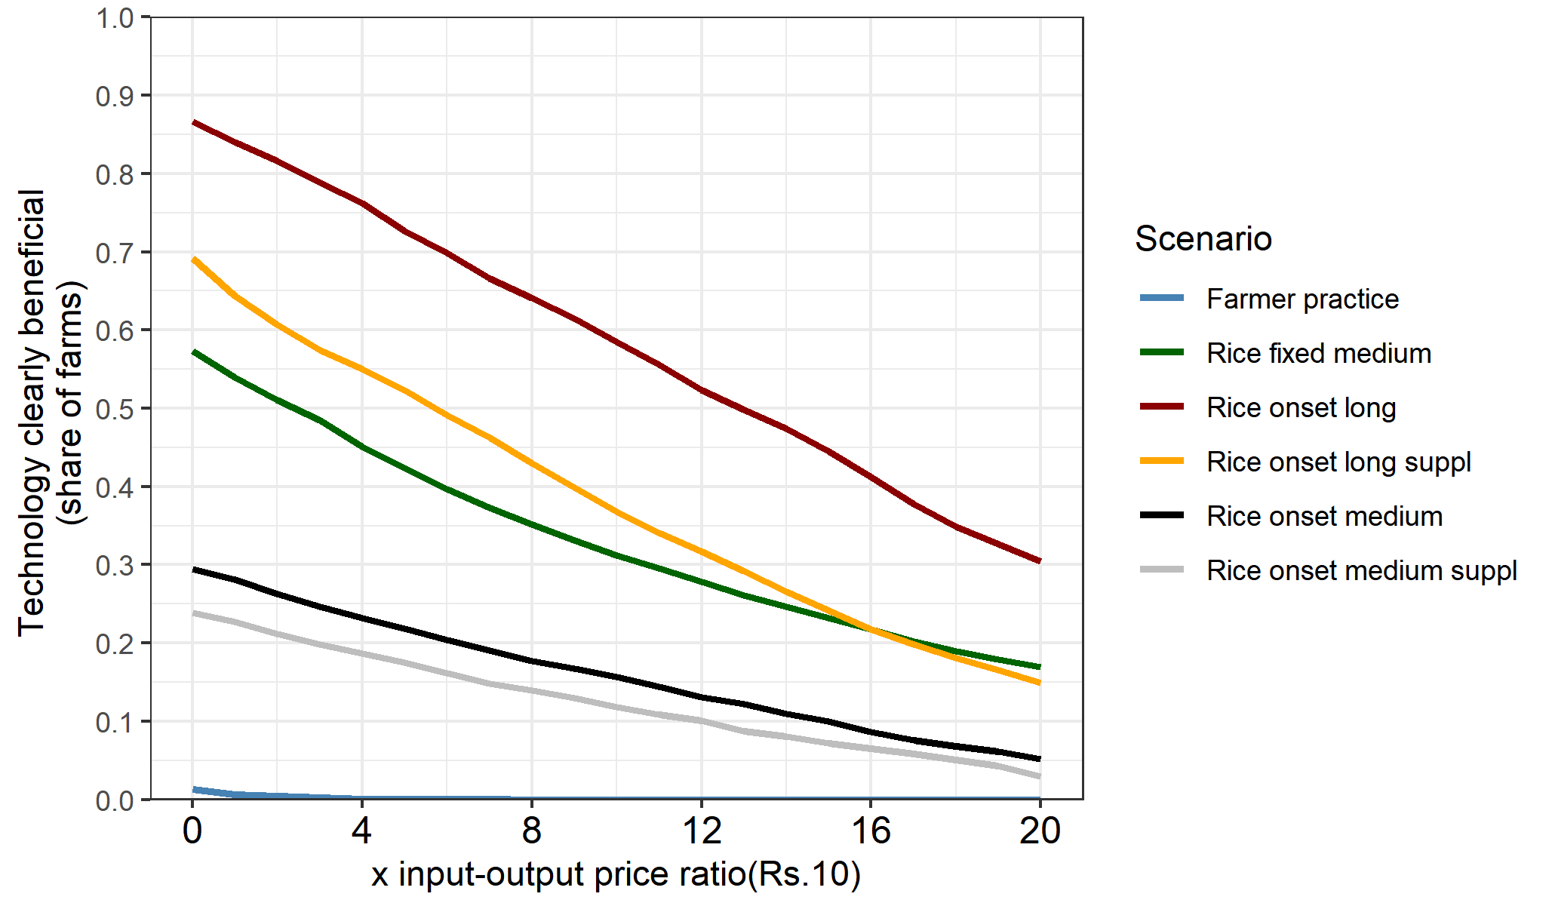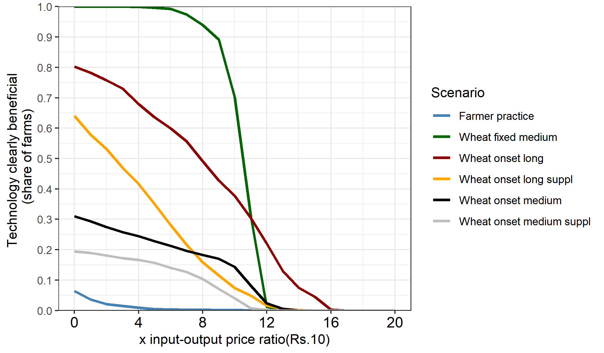

b. With zero yield entries

Rice

Wheat

Figure:

## 3.3. System-wide win-win scenarios and economic trade-offs for a risk averse farmer

We consider next the spatial variation in terms of which pixels benefit the most from these scenarios for rice and wheat. We do this in three ways, First, for each of the scenarios, w classify the pixels into four distinct categories. These are: (1) both rice and wheat are beneficial to risk averse farmer, (2) rice is beneficial but wheat is not beneficial, (3) rice is not beneficial but wheat is beneficial, and (4) both rice and wheat strategies are not beneficial.

The second approach requires computing the system caloric yields and use these in the stochastic dominance computations.

The approach involves using average prices of irrigation water for rice and wheat, and the output price to compute the economic benefits of following each of the scenarios. We then use these economic indicators in the stochastic comparisons.

Figure: Scatter plot of scenario frontier for wheat and rice

Note:

# 4. Conclusion

# References

Harou, A., Liu, Y., Barrent, C.B., and You, L. 2017. “Variable returns to fertiliser use and the geography of poverty: Experimental and simulation evidence from Malawi.” *Journal of African Economies* 26 (3): 342-371. Doi: <https://doi.org/10.1093/jae/ejx002>.

Hurley, T., Koo, J., and Tesfaye, K. 2018. “Weather risk: how does it change the yield benefits of nitrogen fertilizer and improved maize varieties in sub-Saharan Africa?” *Agricultural Economics* 49: 711-723. Doi: 10.1111/agec.12454.

Levy, H. 2016. “Stochastic Dominance: Investment Decision Making under Uncertainty.” Third Edition. Springer.

McCullough, E.B., Quinn, J.D., Simons, A.M. 2020. “Profitability of climate-smart soil fertility investment varies widely across sub-Saharan Africa.” *Nature Food* 3:275-285. Doi: <https://doi.org/10.1038/s43016-022-00493-z>.

Meyer, J.1977. “Second degree stochastic dominance with respect to a function.” *International Economic Review* 18(2): 477-487. Doi: <https://doi.org/10.2307/2525760>.

Suri, T. 2011. “Selection and Comparative Advantage in Technology Adoption.” *Econometrica* 79(1): 159-209. Doi:10.3982/ECTA7749.

Urfels, A., Montes, C., Balwinder-Singh, Halsema, G., Struik, P., Krupnik, T., and McDonald, J. 2022. “Climate adaptative rice planting strategies diverge across environmental gradients in the Indo-Gangetic Plains.” *Environmental Research Letters* 17: 124030. Doi: 10.1088/1748-9326/aca5a2.

# Appendices

**Appendix: Theorem relating second order stochastic dominance to risk aversion**

**Theorem [Meyer (1977, theorem 2)]:** For cumulative distribution functions $F(x)$ and $G(x)$, $\int_{0}^{y}{\left[G\left(x\right)-F\left(x\right)\right]dk\left(x\right)≥0, ∀y∈[0,1]}$

If and only if

$$\int_{0}^{1}{u\left(x\right)dF\left(x\right)≥\int_{0}^{1}{u\left(x\right)dG(x)}}, ∀u\left(x\right)∈U\left(\frac{k''(x)}{k(x)},∞\right)$$

## Appendix: Computing WTP bounds and benefits for risk averse farmer

We follow closely the notation and derivation by Hurley et al (2018). Consider the following notation

$y$: Bounded random yield where $y^{L}≤y≤y^{U}$,

$f^{r}(y)$: Yield density functions for baseline farmer practice

$f^{g}(y)$: Yield density functions for new agronomic innovation

$F^{r}(y)$: Cumulative distribution functions for baseline farmer practice

$F^{g}$: Cumulative distribution functions for new agronomic innovation

A farmer has a trice differentiable, risk averse utility of yield function such that $U^{'}\left(y\right)>0$, and $U^{''}\left(y\right)<0$

A farmer is expected to weakly prefer the new agronomic management innovation if

$$\int_{y^{L}}^{y^{U}}{U\left(y\right)f^{g}\left(y\right)dy≥}\int_{y^{L}}^{y^{U}}{U\left(y\right)}f^{r}\left(y\right)dy$$

One may compare the area under the cumulative distributions

If

$\int_{y^{L}}^{y^{U}}{F^{g}\left(z\right)dz≥}\int_{y^{L}}^{y^{U}}{F^{r}\left(z\right)dz},$ $∀y$

Then the new agricultural innovation will be weakly preferred.

With price risks and production costs,

$$\int_{ϵ}{\int_{p>0}{\int_{y^{L}}^{y^{U}}{U\left(py-c^{g}\right)A)f^{g}\left(y | ϵ\right)dy h\left(p | ϵ\right)dpϕ(ϵ)}}}≥\int_{ϵ}{\int_{p>0}{\int_{y^{L}}^{y^{U}}{U\left(py-c^{r}\right)A)f^{r}\left(y | ϵ\right)dy h\left(p | ϵ\right)dpϕ(ϵ)}}}$$

**WTP question is:** How much wheat/rice per hectare would a risk-averse farmer be willing to give up/pay to use the new agronomic innovation?

**Answer:** It is the $w$ that satisfies,

$$\int_{ϵ}{\int_{p>0}{\int_{y^{L}}^{y^{U}}{U\left(p\left(y-w\right)-c^{g}\right)A)f^{g}\left(y | ϵ\right)dy h\left(p | ϵ\right)dpϕ(ϵ)}}}=\int_{ϵ}{\int_{p>0}{\int_{y^{L}}^{y^{U}}{U\left(py-c^{r}\right)A)f^{r}\left(y | ϵ\right)dy h\left(p | ϵ\right)dpϕ(ϵ)}}}$$

According to Hurley et al (2018), the lower WTP bound that makes any risk-averse farmer prefer new technology (in this case scenarios other than the baseline) can be derived using second order stochastic dominance as follows:

Where is the lower bound for the willingness to pay.

Similarly, for the upper bound,

**If *both lower bound and upper bound are positive***, then any risk averse farmer will prefer $g$ to $r$. Conversely, if *both lower bound and upper bound are negative*, then any risk averse farmer will prefer $r$ to $g$.

To include price information, we simply compare the WTP bounds to the price information

$$kg of wheat required to pay for technology per ha(kg/ha)=\frac{Technology cost per ha \left(\frac{Rs}{ha}\right) }{Price of wheat per kg (\frac{Rs}{kg})}$$

We use Octave for the computational analysis.

## Appendix: Farmer practice as the baseline with zero yield entries

Table: Willingness to pay bound **(rice ton/ha)** descriptive **statistics [Farmer practice as baseline]**

|  |  |  |  |  |  |  |  |
| --- | --- | --- | --- | --- | --- | --- | --- |
| Bound | Statistics | S1-S0 | S2-S0 | S3-S0 | S4-S0 | S5-S0 | S6-S0 |
| Upper bound | Weighted Mean_UB | 3.21 | 4.91 | 5.86 | 5.38 | 3.87 | 3.73 |
| Weighted SD_UB | 1.44 | 0.65 | 0.93 | 1.15 | 0.62 | 0.78 |
| Min_UB | -0.76 | 2.39 | 0.34 | -0.56 | 1.38 | -2.55 |
| Percentile10_UB | 1.82 | 4.43 | 4.92 | 3.87 | 3.40 | 2.57 |
| Percentile25_UB | 2.06 | 4.66 | 5.52 | 5.14 | 3.70 | 3.65 |
| Median_UB | 3.07 | 4.98 | 5.89 | 5.57 | 3.95 | 3.87 |
| Percentile75_UB | 4.28 | 5.27 | 6.38 | 6.05 | 4.19 | 4.12 |
| Percentile90_UB | 5.31 | 5.53 | 6.74 | 6.47 | 4.40 | 4.34 |
| Max_UB | 6.59 | 6.62 | 8.28 | 7.82 | 5.40 | 5.30 |
| Lower bound | WeightedMean_LB | 0.84 | 2.13 | 3.19 | 2.59 | 1.08 | 0.90 |
| WeightedSD_LB | 1.57 | 1.78 | 1.57 | 1.60 | 1.80 | 1.81 |
| Min_LB | -4.88 | -1.15 | -0.99 | -4.89 | -2.49 | -5.45 |
| Percentile10_LB | -1.87 | -0.11 | 1.28 | 0.73 | -1.18 | -1.27 |
| Percentile25_LB | 0.41 | 0.53 | 1.87 | 1.47 | -0.51 | -0.61 |
| Median_LB | 1.69 | 1.90 | 2.90 | 2.24 | 0.81 | 0.45 |
| Percentile75_LB | 1.87 | 4.03 | 4.82 | 3.95 | 2.97 | 2.80 |
| Percentile90_LB | 1.92 | 4.56 | 5.34 | 4.94 | 3.53 | 3.46 |
| Max_LB | 2.20 | 5.48 | 6.65 | 6.13 | 4.26 | 4.18 |
|  | Clearly better (share) | 0.79 | 0.87 | 1.00 | 0.95 | 0.64 | 0.57 |
| Not clear | 0.19 | 0.13 | 0.00 | 0.05 | 0.36 | 0.43 |
| Clearly worse (share) | 0.01 | 0.00 | 0.00 | 0.00 | 0.00 | 0.00 |
| Total hectares | 3386.00 | 3386.00 | 3386.00 | 3386.00 | 3386.00 | 3386.00 |
| Number of cells | 3386.00 | 3386.00 | 3386.00 | 3386.00 | 3386.00 | 3386.00 |

Note:

Table: Willingness to pay bound **(wheat ton/ha)** descriptive statistics **[Farmer practice as baseline]**

|  |  |  |  |  |  |  |  |
| --- | --- | --- | --- | --- | --- | --- | --- |
| Bound | Statistics | S1-S0 | S2-S0 | S3-S0 | S4-S0 | S5-S0 | S6-S0 |
| Upper bound | Weighted Mean_UB | 1.71 | 2.90 | 2.79 | 2.17 | 1.70 | 3.59 |
| Weighted SD_UB | 1.23 | 1.18 | 1.13 | 1.27 | 1.21 | 51.45 |
| Min_UB | -1.34 | -0.02 | -0.25 | -3.32 | -0.71 | -3.32 |
| Percentile10_UB | 0.00 | 1.20 | 1.24 | 0.54 | -0.09 | -0.48 |
| Percentile25_UB | 0.01 | 1.37 | 1.51 | 1.00 | 1.11 | 0.21 |
| Median_UB | 2.11 | 3.31 | 3.04 | 2.38 | 1.62 | 0.76 |
| Percentile75_UB | 2.64 | 3.77 | 3.61 | 3.15 | 2.45 | 1.45 |
| Percentile90_UB | 3.13 | 4.21 | 4.24 | 3.76 | 3.27 | 2.71 |
| Max_UB | 3.72 | 4.70 | 4.84 | 4.64 | 4.78 | 1000.00 |
| Lower bound | WeightedMean_LB | 0.34 | 1.46 | 1.25 | 0.65 | 0.39 | 2.26 |
| WeightedSD_LB | 0.98 | 0.94 | 0.74 | 1.07 | 0.94 | 51.52 |
| Min_LB | -1.59 | -0.42 | -1.03 | -4.67 | -1.29 | -4.63 |
| Percentile10_LB | -0.59 | 0.55 | 0.51 | -0.15 | -0.60 | -1.79 |
| Percentile25_LB | -0.33 | 0.84 | 0.79 | 0.28 | -0.32 | -1.16 |
| Median_LB | -0.05 | 1.12 | 1.09 | 0.65 | 0.24 | -0.41 |
| Percentile75_LB | 1.16 | 2.16 | 1.54 | 1.07 | 0.91 | 0.21 |
| Percentile90_LB | 1.98 | 3.02 | 2.36 | 1.98 | 1.27 | 0.86 |
| Max_LB | 2.60 | 3.74 | 4.03 | 3.77 | 3.61 | 1000.00 |
|  | Clearly better (share) | 0.42 | 0.99 | 0.99 | 0.86 | 0.59 | 0.38 |
| Not clear | 0.52 | 0.01 | 0.01 | 0.13 | 0.29 | 0.46 |
| Clearly worse (share) | 0.06 | 0.00 | 0.00 | 0.01 | 0.11 | 0.17 |
| Total hectares | 3386.00 | 3386.00 | 3386.00 | 3386.00 | 3386.00 | 3386.00 |
| Number of cells | 3386.00 | 3386.00 | 3386.00 | 3386.00 | 3386.00 | 3386.00 |

Note:

Appendix: Fixed long as baseline with zero yield entries

Table: **Rice WTP bounds** with fized long as baseline [with zero yield entries]

|  |  |  |  |  |  |  |  |
| --- | --- | --- | --- | --- | --- | --- | --- |
| Bound | Statistics | S0-S1 | S2-S1 | S3-S1 | S4-S1 | S5-S1 | S6-S1 |
| Upper bound | Weighted Mean_UB | -0.84 | 2.92 | 3.95 | 3.57 | 1.91 | 1.80 |
| Weighted SD_UB | 1.57 | 0.41 | 0.62 | 0.63 | 0.35 | 0.45 |
| Min_UB | -2.20 | 2.27 | 2.89 | -1.75 | 1.29 | -1.95 |
| Percentile10_UB | -1.92 | 2.50 | 3.18 | 3.03 | 1.55 | 1.45 |
| Percentile25_UB | -1.87 | 2.61 | 3.44 | 3.20 | 1.64 | 1.60 |
| Median_UB | -1.69 | 2.79 | 3.85 | 3.48 | 1.84 | 1.79 |
| Percentile75_UB | -0.41 | 3.18 | 4.40 | 3.95 | 2.13 | 2.03 |
| Percentile90_UB | 1.86 | 3.49 | 4.85 | 4.37 | 2.40 | 2.31 |
| Max_UB | 4.88 | 4.19 | 5.73 | 5.33 | 3.12 | 2.97 |
| Lower bound | WeightedMean_LB | -3.21 | 0.44 | 1.43 | 0.73 | -0.61 | -0.86 |
| WeightedSD_LB | 1.44 | 1.38 | 1.23 | 1.18 | 1.33 | 1.28 |
| Min_LB | -6.59 | -1.73 | -1.71 | -3.91 | -2.66 | -3.04 |
| Percentile10_LB | -5.31 | -1.31 | -0.10 | -0.44 | -2.24 | -2.29 |
| Percentile25_LB | -4.28 | -0.66 | 0.43 | -0.12 | -1.68 | -1.91 |
| Median_LB | -3.08 | 0.25 | 1.29 | 0.57 | -0.84 | -1.14 |
| Percentile75_LB | -2.06 | 1.37 | 2.27 | 1.47 | 0.28 | -0.08 |
| Percentile90_LB | -1.82 | 2.68 | 3.25 | 2.39 | 1.49 | 1.20 |
| Max_LB | 0.76 | 3.69 | 4.79 | 4.37 | 2.45 | 2.35 |
|  | Clearly better (share) | 0.01 | 0.57 | 0.87 | 0.69 | 0.29 | 0.24 |
| Not clear | 0.19 | 0.43 | 0.13 | 0.30 | 0.71 | 0.75 |
| Clearly worse (share) | 0.79 | 0.00 | 0.00 | 0.00 | 0.00 | 0.01 |
| Total hectares | 3386.00 | 3386.00 | 3386.00 | 3386.00 | 3386.00 | 3386.00 |
| Number of cells | 3386.00 | 3386.00 | 3386.00 | 3386.00 | 3386.00 | 3386.00 |

Table: **Wheat WTP bounds** with fixed long as baseline [with zero yield entries]

|  |  |  |  |  |  |  |  |
| --- | --- | --- | --- | --- | --- | --- | --- |
| Bound | Statistics | S0-S1 | S2-S1 | S3-S1 | S4-S1 | S5-S1 | S6-S1 |
| Upper bound | Weighted Mean_UB | -0.34 | 1.28 | 1.23 | 0.64 | 0.20 | -0.37 |
| Weighted SD_UB | 0.98 | 0.12 | 0.38 | 0.69 | 0.76 | 1.03 |
| Min_UB | -2.60 | 0.60 | 0.18 | -2.39 | -1.11 | -2.39 |
| Percentile10_UB | -1.98 | 1.15 | 0.64 | -0.09 | -0.80 | -1.78 |
| Percentile25_UB | -1.16 | 1.23 | 0.98 | 0.48 | -0.37 | -1.22 |
| Median_UB | 0.05 | 1.30 | 1.29 | 0.75 | 0.11 | -0.36 |
| Percentile75_UB | 0.32 | 1.37 | 1.50 | 1.04 | 0.82 | 0.47 |
| Percentile90_UB | 0.59 | 1.40 | 1.65 | 1.25 | 1.32 | 1.10 |
| Max_UB | 1.59 | 1.53 | 2.05 | 1.91 | 1.69 | 1.61 |
| Lower bound | WeightedMean_LB | -1.71 | 1.03 | 0.66 | 0.04 | -0.24 | -1.15 |
| WeightedSD_LB | 1.23 | 0.12 | 0.61 | 0.90 | 0.78 | 1.10 |
| Min_LB | -3.72 | 0.38 | -0.89 | -3.47 | -1.42 | -3.72 |
| Percentile10_LB | -3.13 | 0.88 | -0.26 | -1.04 | -1.08 | -2.18 |
| Percentile25_LB | -2.64 | 0.98 | 0.23 | -0.34 | -0.87 | -1.88 |
| Median_LB | -2.11 | 1.06 | 0.78 | 0.25 | -0.47 | -1.60 |
| Percentile75_LB | -0.01 | 1.11 | 1.17 | 0.64 | 0.36 | -0.49 |
| Percentile90_LB | 0.00 | 1.15 | 1.34 | 0.93 | 1.07 | 0.81 |
| Max_LB | 1.34 | 1.24 | 1.62 | 1.49 | 1.35 | 1.23 |
|  | Clearly better (share) | 0.06 | 1.00 | 0.80 | 0.64 | 0.31 | 0.19 |
| Not clear | 0.52 | 0.00 | 0.20 | 0.25 | 0.25 | 0.19 |
| Clearly worse (share) | 0.42 | 0.00 | 0.00 | 0.11 | 0.44 | 0.62 |
| Total hectares | 3386.00 | 3386.00 | 3386.00 | 3386.00 | 3386.00 | 3386.00 |
| Number of cells | 3386.00 | 3386.00 | 3386.00 | 3386.00 | 3386.00 | 3386.00 |